- There was a downside surprise for UK CPI inflation in January as a particularly large month-on-month fall in services prices mitigated the impact of a rise in the energy price cap. We still expect inflation will fall sharply in the coming months, and we see the CPI measure averaging 2.1% in 2024.
- But the annual update of the weights mean we now forecast inflation will be slightly higher in 2025-2026. The weights on sectors we expect to have smaller price rises have been cut.
CPI inflation held steady at 4%.in January We had expected a higher reading, largely because of the strength of base effects caused by the large m/m drop in services prices in January 2023. But there was a chunky m/m fall in services sector prices this January too. This was partly due to the impact of the normal January fall in air fares being amplified by the ONS more than doubling the component's weight in the CPI basket. This contributed to a softer than expected reading for core inflation, which offset the impact of a 5% increase in the Ofgem energy price cap on headline inflation. Elsewhere, RPI inflation fell to 4.9% in January from 5.2% in December, while RPIX declined to 3.8% from 4%.
We think CPI inflation will cool rapidly in the coming months. This is largely due to lower wholesale gas prices, which should mean the Ofgem energy price cap falls by around 14% in April. But downward pressures will come from elsewhere too. The indirect effects of lower energy prices should continue to cool core goods and services inflation, while base effects are likely to help food price inflation ease further.
We still expect CPI inflation to average 2.1% this year. But further out, our inflation forecast is higher than before. This is partly due to base effects caused by this year's larger fall in energy prices. But it also reflects the impact of the annual reweighting of the inflation basket. The ONS has lowered the weights on some of the components we expect to weigh on headline inflation in 2025-2026, such as food and energy. Meanwhile, a higher weight has been assigned to services prices, which boost headline inflation. So incorporating the month's weight changes into our forecast means we now see CPI inflation slightly above the Bank of England's 2% target in 2025-2026.
Chart 1: We still forecast CPI inflation to average 2.1% this year
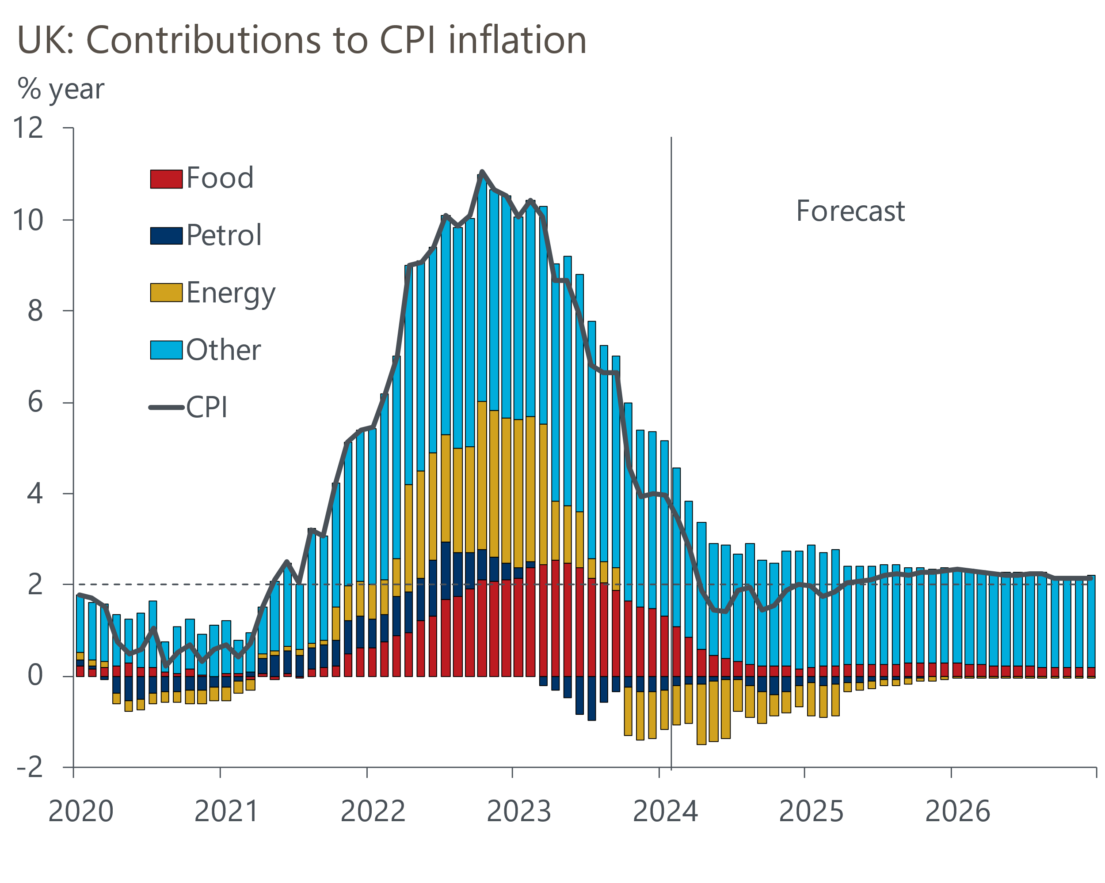
Source: Oxford Economics, Haver Analytics

